**Spring Data JPA - Quick Example**

**Step-1: Created a Eclipse Project using Spring Initializr**

**Step-2:** Created ormlearm schema in mysql and then created a country table and inserted two values

create table country(co_code varchar(2) primary key, co_name varchar(50));

insert into country values ('IN', 'India');

insert into country values ('US', 'United States of America');

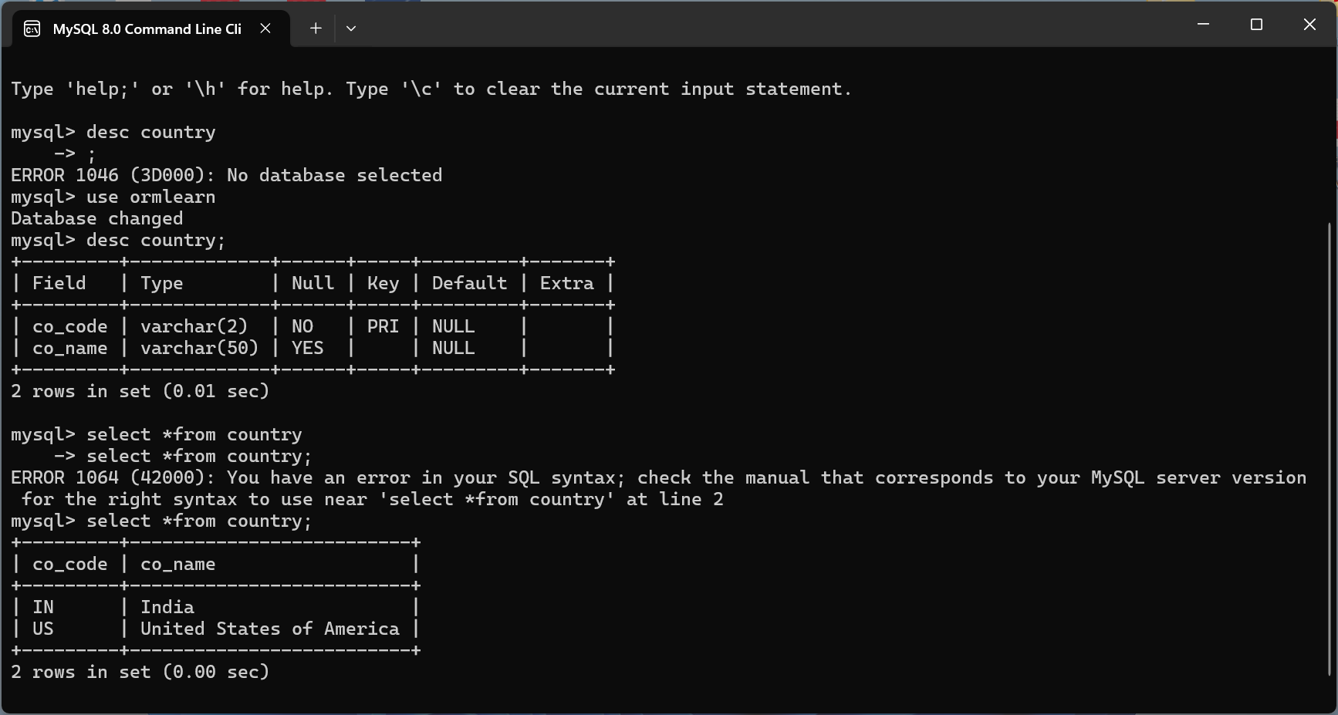

Step-3: Created required country class ,CounterRepository Class and Countryservice class in eclipse .

**Persistence Class - com.cognizant.orm-learn.model.Country**

**Country.java**

**package** com.cognizant.orm_learn.model;

**import** javax.persistence.Column;

**import** javax.persistence.Entity;

**import** javax.persistence.Id;

**import** javax.persistence.Table;

@Entity

@Table(name = "country")

**public** **class** Country {

@Id

@Column(name = "co_code")

**private** String code;

@Column(name = "co_name")

**private** String name;

// Getters & Setters

**public** String getCode() { **return** code; }

**public** **void** setCode(String code) { **this**.code = code; }

**public** String getName() { **return** name; }

**public** **void** setName(String name) { **this**.name = name; }

@Override

**public** String toString() {

**return** "Country{" + "code='" + code + '\'' + ", name='" + name + '\'' + '}';

}

}

**Repository Class - com.cognizant.orm-learn.CountryRepository**

**CounterRepository.java**

**package** com.cognizant.orm_learn.repository;

**import** org.springframework.data.jpa.repository.JpaRepository;

**import** org.springframework.stereotype.Repository;

**import** com.cognizant.orm_learn.model.Country;

@Repository

**public** **interface** CountryRepository **extends** JpaRepository<Country, String> {

}

**Service Class - com.cognizant.orm-learn.service.CountryService**

**CountryService.java**

**package** com.cognizant.orm_learn.service;

**import** java.util.List;

**import** org.springframework.beans.factory.annotation.Autowired;

**import** org.springframework.stereotype.Service;

**import** org.springframework.transaction.annotation.Transactional;

**import** com.cognizant.orm_learn.model.Country;

**import** com.cognizant.orm_learn.repository.CountryRepository;

@Service

**public** **class** CountryService {

@Autowired

**private** CountryRepository countryRepository;

@Transactional

**public** List<Country> getAllCountries() {

**return** countryRepository.findAll();

}

}

**Step-4: Application.properties**

spring.application.name=orm-learn

# Spring Framework and application log

logging.level.org.springframework=info

logging.level.com.cognizant=debug

# Hibernate logs for displaying executed SQL, input and output

logging.level.org.hibernate.SQL=trace

logging.level.org.hibernate.type.descriptor.sql=trace

# Log pattern

logging.pattern.console=%d{dd-MM-yy} %d{HH:mm:ss.SSS} %-20.20thread %5p %-25.25logger**{25}** %25M %4L %m%n

# Database configuration

spring.datasource.driver-class-name=com.mysql.cj.jdbc.Driver

spring.datasource.url=jdbc:mysql://localhost:3306/ormlearn

spring.datasource.username=root

spring.datasource.password=*******

# Hibernate configuration

spring.jpa.hibernate.ddl-auto=validate

spring.jpa.properties.hibernate.dialect=org.hibernate.dialect.MySQL8Dialect

**Step-5: main class**

**Testing in OrmLearnApplication.java**

**OrmLearnApplication.java**

**package** com.cognizant.orm_learn;

**import** java.util.List;

**import** org.slf4j.Logger;

**import** org.slf4j.LoggerFactory;

**import** org.springframework.boot.SpringApplication;

**import** org.springframework.boot.autoconfigure.SpringBootApplication;

**import** org.springframework.context.ApplicationContext;

**import** com.cognizant.orm_learn.model.Country;

**import** com.cognizant.orm_learn.service.CountryService;

@SpringBootApplication

**public** **class** OrmLearnApplication {

**private** **static** **final** Logger ***LOGGER*** = LoggerFactory.*getLogger*(OrmLearnApplication.**class**);

**private** **static** CountryService *countryService*;

**public** **static** **void** main(String[] args) {

ApplicationContext context = SpringApplication.*run*(OrmLearnApplication.**class**, args);

***LOGGER***.info("Inside main");

*countryService* = context.getBean(CountryService.**class**);

*testGetAllCountries*();

}

**private** **static** **void** testGetAllCountries() {

***LOGGER***.info("Start");

List<Country> countries = *countryService*.getAllCountries();

***LOGGER***.debug("countries = {}", countries);

***LOGGER***.info("End");

}

}

**Output:**

